Ruteo Estático

Dispositivo | Interfaz | Dirección IP | Máscara de Subred | Gateway por defecto
R1 | F 0/0 | 168.168.6.126 | /25 | NA
R1 | F 0/1 | 168.168.6.190 | /26 | NA
R1 | S 0/3/0 | 1.2.3.1 | /30 | NA
R2 | F 0/0 | 172.154.6.126 | /25 | NA
R2 | F 0/1 | 172.154.6.158 | /27 | NA
R2 | S 0/3/0 | 1.2.3.2 | /30 | NA
A1 | NIC | 168.168.6.1 | /25 | 168.168.6.126
A2 | NIC | 168.168.6.2 | /25 | 168.168.6.126
A3 | NIC | 168.168.6.3 | /25 | 168.168.6.126
B1 | NIC | 168.168.6.130 | /26 | 168.168.6.190
B2 | NIC | 168.168.6.131 | /26 | 168.168.6.190
B3 | NIC | 168.168.6.132 | /26 | 168.168.6.190
C1 | NIC | 172.154.6.1 | /25 | 172.154.6.126
C2 | NIC | 172.154.6.2 | /25 | 172.154.6.126
C3 | NIC | 172.154.6.3 | /25 | 172.154.6.126
D1 | NIC | 172.154.6.130 | /27 | 172.154.6.158
D2 | NIC | 172.154.6.131 | /27 | 172.154.6.158
D3 | NIC | 172.154.6.132 | /27 | 172.154.6.158

Subred | Dirección IP de la subred | Máscara de subred | Cantidad de host | Primera dirección | Última dirección
A | 168.168.6.0 | /25 | 126 | 168.168.6.1 | 168.168.6.126
B | 168.168.6.128 | /26 | 62 | 168.168.6.129 | 168.168.6.190
C | 172.154.6.0 | /25 | 126 | 172.154.6.1 | 172.154.6.126
D | 172.154.6.128 | /27 | 30 | 172.154.6.129 | 172.154.6.158

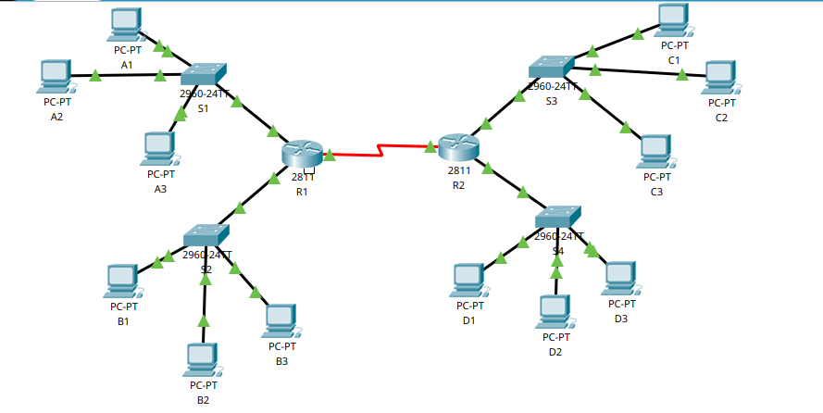
TOPOLOGIA DE LA RED

